Experimental Head Loss Determination for Water Flow Through a Pipe Using a Pressure Transducer

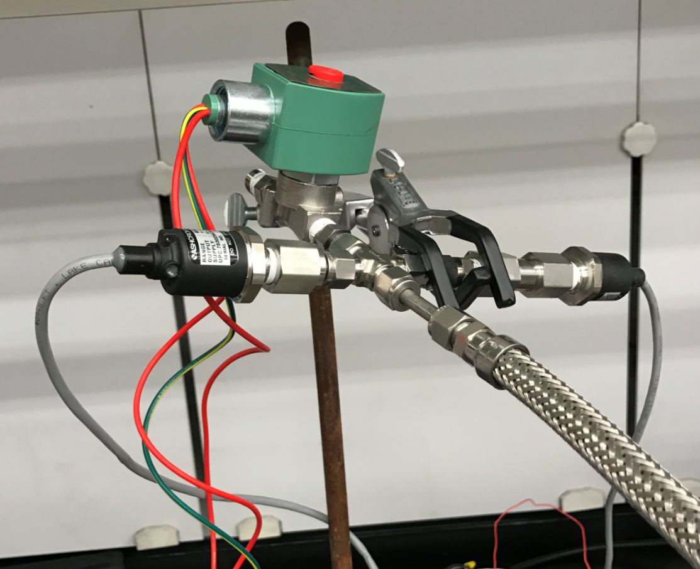

Johnny Froelich: Report writing and data analysis

James Luce: Experiment design, data analysis, and report writing

Rawand Rasheed: Report Writing, and conducted experiment

Michelle Shang: Experiment design, data acquisition, and setup

Jonathan Talik: Experiment design, setup, and conducted experiment

ME411: Final Report

March 23, 2017

**1.Introduction:**

This experiment was conducted by the Portland State Aerospace Society (PSAS) Electric Feed System (EFS) capstone team. The goal of the EFS project is to design an electric powered fuel pump for an amateur rocket. The requirements of the rocket dictate that the pump output liquid oxygen at high head and low flow rate outside of a typical pump sizing regime. In developing the pump, it is critical to accurately characterize the head losses associated with the pump. Pressure and flow rate measurements will be used to characterize the head losses in the pump. In this experiment, a pressure transducer is calibrated using known pressures. The calibrated transducer is used to measure pressure of water flowing through a pipe. Using a bucket, stopwatch, and a ruler, flowrate at the outlet of the pipe is measured. The objective is to characterize the head loss through the pipe experimentally in order to establish an experimental method that will later be used for head loss measurements on a pump.

1.1 Theory

The objective of this experiment is to measure flowrate and pressure in a system in order to experimentally determine the head losses of the system. Pressure measurements are taken from a pressure transducer, and flow rate measurements are taken from a bucket and stopwatch. The mechanical energy equation for fluids is used to characterize the losses in the system,

$\frac{P_{1}}{γ}+\frac{v_{1}^{2}}{g}+z_{1}=\frac{P_{2}}{γ}+\frac{v_{2}^{2}}{g}+z_{2}+$ $h_{f}$ (1)

where P is pressure, $γ$ is specific weight, z is height, v is fluid velocity, and $h_{f}$ is head loss. Point 1 is the point where the pressure transducer is mounted in the system, and point 2 is the outlet of the system. For Equation (1) to be implemented, it is assumed that the fluid flow is incompressible. This assumption is valid for water, the fluid used in this experiment. Volumetric flow rate is also assumed to be constant and is given by,

$Q=VA$ (2)

where Q is the volumetric flow rate, V is fluid velocity, and A is the cross sectional area of the flow passage, a circular pipe in this experiment. Using the height at point 2 as the datum for the system and taking P2, the outlet pressure, to be atmospheric, Equation (1) is simplified and solved for head losses,

$h_{f}=\frac{P_{1}}{γ}+\frac{v_{1}^{2}}{g}-\frac{v_{2}^{2}}{g}+z_{1}$ (3)

Combining Equations (2) and (3), head loss in terms of volumetric flow rate is derived,

$h_{f}=\frac{P_{1}}{γ}+\frac{Q_{}^{2}}{g}(\frac{1}{A_{1}^{2}}-\frac{1}{A_{2}^{2}})+z_{1}$ (4)

Experimentally measured values for pressure and volumetric flow rate are used to attain experimental head loss from Equation (4). Experimental head loss values will be compared to what is expected in theory in order to determine the robustness of the experimental method for use in determining head losses in a pump.

1.2 Instruments and Measurement Techniques

Diaphragm pressure transducers are an effective means of measuring pressure of a fluid. These types of pressure transducers use an elastic diaphragm element which deforms when a pressure differential is experienced across the top and bottom of the diaphragm. The deformation of the diaphragm is converted to an electrical signal, usually a change in voltage output, that is proportional to the pressure difference experienced [1]. The diaphragm pressure transducer used in this experiment also includes a translation medium, which improves the accuracy of the transducer measurements throughout a larger range of temperatures. Fig. 1 shows a schematic of the Ashcroft G2 pressure transducer used in this experiment [5].

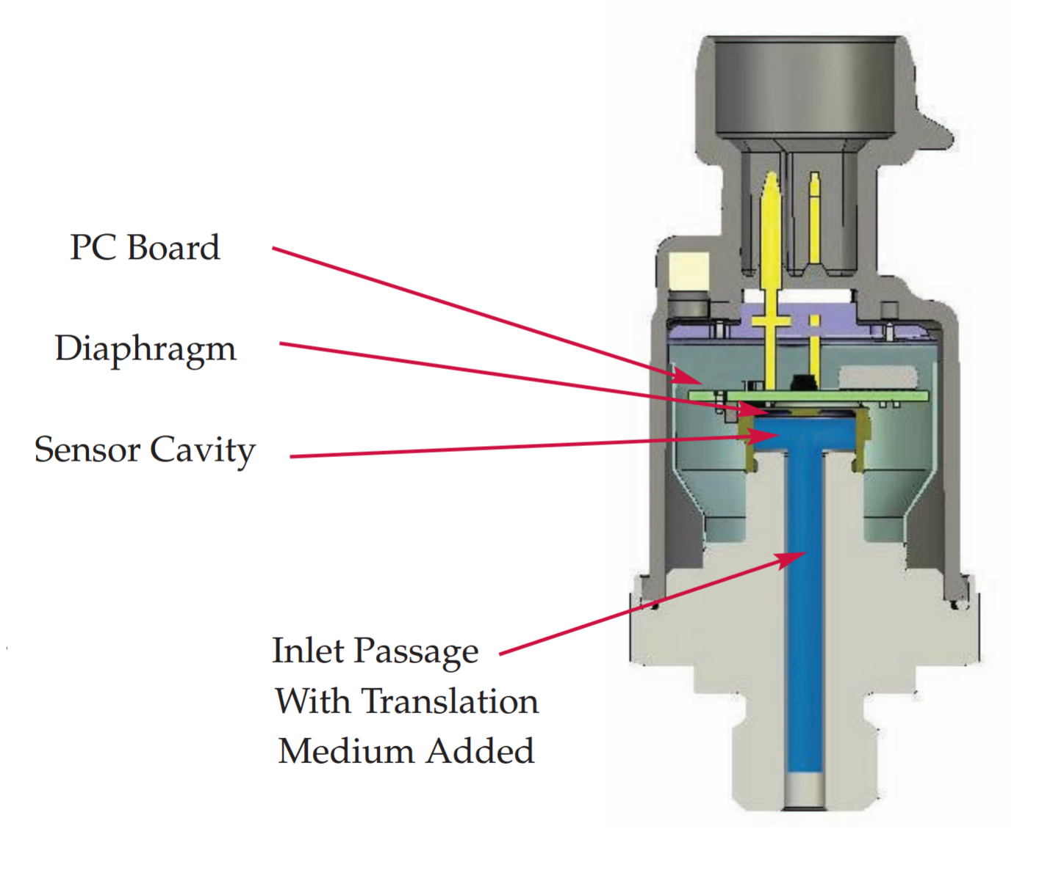

*Figure 1 - Schematic of the Ashcroft G2 sensor used for taking pressure measurements in this experiment. Shown is the sensor cavity, diaphragm, and PC Board. The diaphragm deflects when subject to a pressure through the sensor cavity. Deflection of the diaphragm results in a change in voltage output from the pressure transducer [5].*

The flowrate of the fluid flow through the system is characterized using a simple bucket and stopwatch method. This form of volumetric flow measurement is known to be a very accurate method [2]. Although redirection and incontinuity of the fluid flow required for this method will not be possible in the final flight ready engine pump, the bucket and stopwatch method is valuable for testing the flow rate of the pump prototypes produced for the EFS project.

**2. Methods:**

2.1: Experimental Setup

Calibration of the Ashcroft G2 pressure transducer used in this experiment is conducted using a pressurized nitrogen tank, a ProStar pressure regulator, 5/16” inner diameter rigid tubing, 5/16” inner diameter fittings, an ASCO 8262h214 2200 Psi shutoff valve, and an Arduino UNO. The nitrogen tank is fitted with a pressure regulator used to specify a pressure between 0 and 750 Psi. Tubing and fittings are used to connect the pressure transducer to the pressure regulator, with a shut off valve connected at the end of the tubing. This creates a chamber of known pressure between the pressure regulator and valve. The shut off valve is used to suddenly open the pressurized line in order to depressurize the chamber for pressure transducer step response characterization. Fig. 2 shows a schematic of the experimental setup used for pressure transducer calibration and transient response characterization.

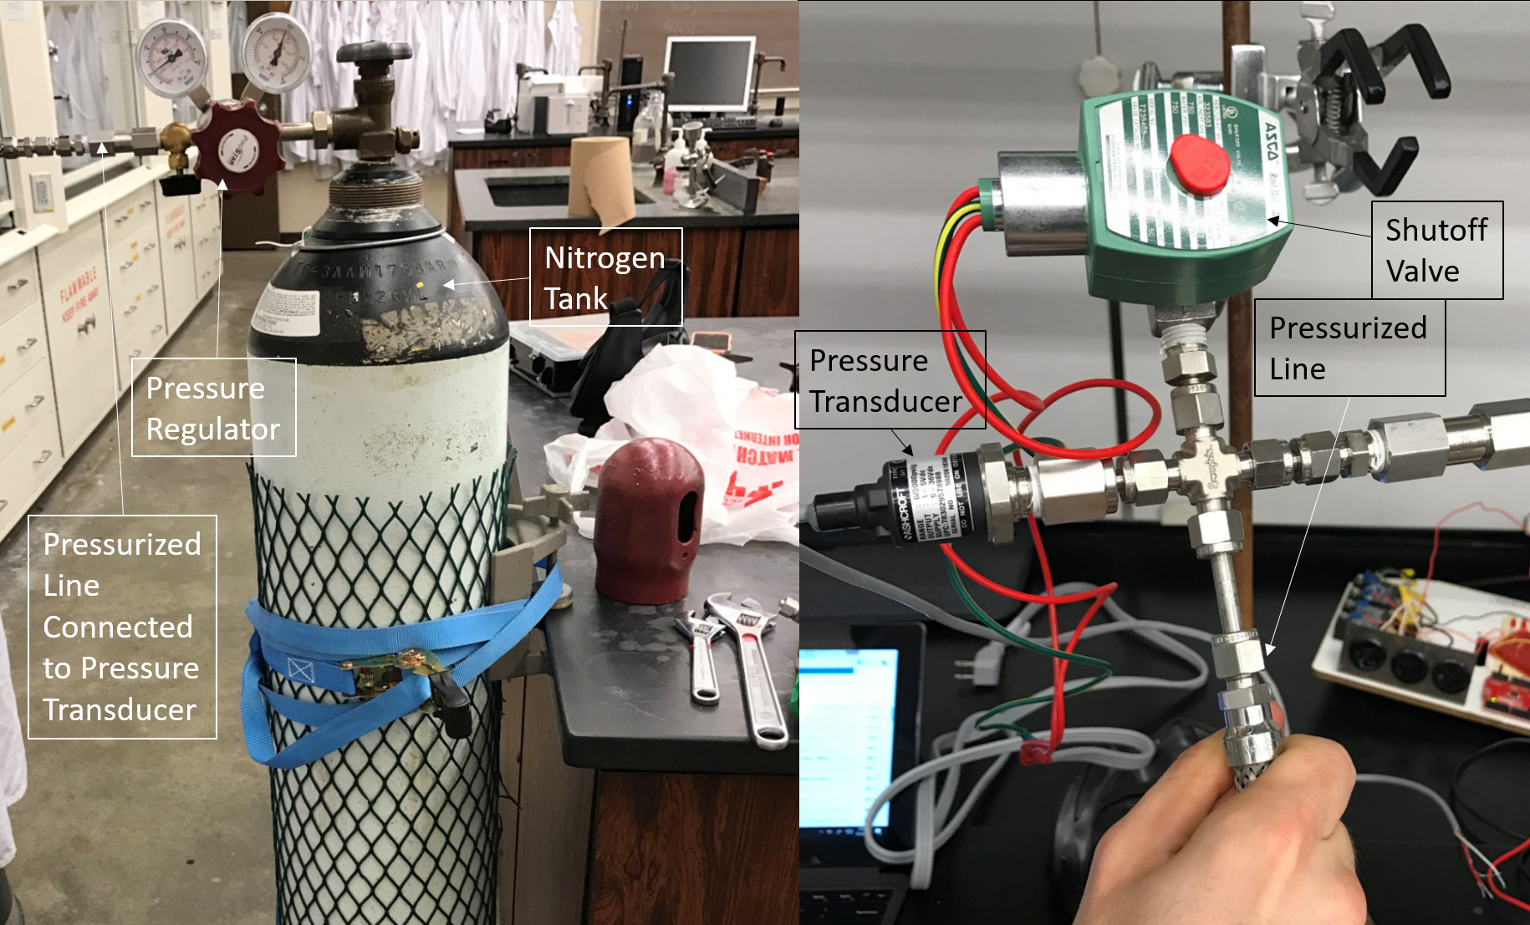

*Figure 2 - Apparatus used for calibration of the pressure transducer. Voltage output of the pressure transducer at known pressures from the pressure regulator are measured using an Arduino UNO, and is logged using a LabView VI. The shutoff valve is used to suddenly open the pressurized line to the atmosphere in order to characterize the response time of the pressure transducer.*

A second experimental setup is used for the flow measurements. A bucket, a ruler, a 6 ft hose, ball valve, and a 3/4” expansion fitting are added to the original list of materials for the flow measurement apparatus. Tubing is connected to a faucet and the pressure transducer is attached in-line downstream from the faucet. The globe valve and expansion fitting are placed in the system after the pressure transducer. The expansion fitting is connected to the hose. Fig. 3 shows the apparatus used in the water flow experiments.

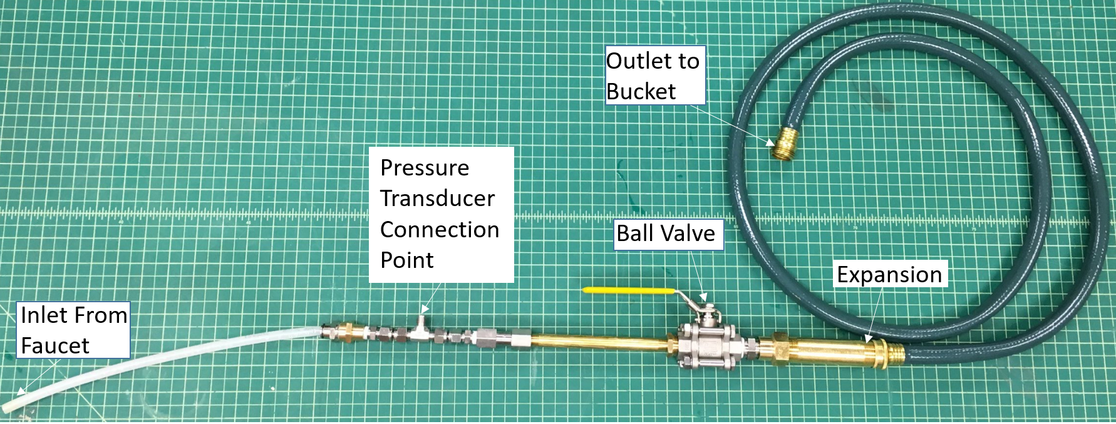

*Figure 3 - Piping system setup for flow measurements. A faucet provides water into the system. Pressure measurements and volumetric flow measurements are taken without the ball valve in the system, and with the ball valve in the system at various ball valve openings.*

Data is collected using a LabView VI. The pressure transducer is powered by a 12 Volt DC power supply. The output signal from the transducer is sent to an Arduino Uno, connected to a computer with a LabView VI. The Arduino interfaces with Labview using the LINX add on by LabView MakerHub [4]. The LabView VI reads data from the Arduino, and stores it in a text file. Fig. A1 in the appendix shows a schematic of the LabView VI used.

2.2: Procedure

2.2.1: Calibration and Response Time Characterization of Pressure Transducer

The Ashcroft G2 pressure transducer is used for all measurements in this experiment. This sensor is specified to measure pressure in the range of 0-3000 Psi at +/- 1.00% accuracy [3]. The first part of this experiment involves calibration of the pressure transducer. A tank of pressurized nitrogen at 2000 Psi is fitted with a pressure regulator with an accuracy of +/- 2.5 Psi that is used to pressurize a hose connected to the pressure transducer. The end of this hose is sealed with an Asco shutoff valve. The shutoff valve allows venting of the pressurized line by opening and allowing the nitrogen to leave the system.

The valve is first closed, after which the pressure regulator is set to a specified pressure. For each pressure, the gage reading is recorded and voltage output readings are taken from the pressure transducer. The pressure transducer is subject to pressures between 0 to 700 Psi at increments of 50 Psi. These known pressures along with their respective output from the pressure transducer are used to construct a calibration curve for the pressure transducer. Table A1 in the appendix shows sample raw output data from the static pressure test at 400 Psi.

Characterization of the pressure transducer response time is carried out using the shutoff valve to create a sudden change in pressure in the line. The system is pressurized to 200 Psi. Data is logged for a few seconds before the shutoff valve is switched open. The nitrogen escapes the pressurized line leaving the transducer subjected to atmospheric pressure. The resulting data is logged in the LabView VI. Step response experiments are conducted at 200, 400, and 600 Psi for a total of three trials per pressure. Table A1 in the appendix shows sample raw output data from the step response experiment at 400 Psi.

2.2.1: Pressure and Volumetric Flow Rate Measurements

Experiments involving pressure and volumetric flow rate through a piping system are conducted after pressure transducer calibration. The experiments aim to measure flow rate and pressure through the system in order to characterize head losses in the system. The experimental apparatus used contains several different lengths of pipe with different friction factors, an expansion, and a ball valve. The first experiment involved no ball valve in the pipe system. The faucet supplying water to the system was opened to provide maximum flow from the faucet. Data logging was initiated on LabView, and once pressure readings held a steady value, a stopwatch timer was initiated. At the same instant, another group member routed the hose outlet into a bucket. After a specified interval of time, the hose is taken out of the bucket. The elapsed time and height of the water is measured and recorded. A ruler with an accuracy of +/- 0.05 inches is used to measure the height of the water, and bucket diameter. The data logged from the pressure transducer pressure measurements is saved. This same experiment is conducted for a total of 3 trials. The second experimental setup incorporates a ball valve in the system. The ball valve is set to 75, 80, 85, and 90 degrees turned where 0 degrees is fully open, and 90 degrees is fully closed. A total of four experiments were conducted at each ball valve setting. Table A1 in the appendix shows sample raw output data from one such water flow experiment.

**3. Results/Discussion:**

3.1: Static Calibration and Transient Response

Data collected from the pressure transducer at varying static pressures results in a linear plot of sensor Voltage Output vs. Applied Pressure. Fig. A2 in the appendix shows a plot of the calibration curve for the pressure transducer. The linear relationship between voltage and pressure is,

$Voltage=0.0013(psi)+1.0152$

with an R squared value of 0.999. The manufacturer's specs [3] state a calibration equation of,

$Voltage=0.00121(psi)+1.0$

which is within 6.32% of the experimentally determined calibration curve for any given pressure measurement. This minor discrepancy between manufacturer calibration and experimental calibration is possibly the result of different data acquisition methods, and different measurement circuit set up.

In the next part of the experiment, a step input is applied to the system by pressurizing the static chamber, and then opening the solenoid valve to quickly drop the pressure applied to the transducer to atmospheric pressure. Due to the time it takes for the nitrogen to move through the solenoid valve, the drop to atmospheric pressure is not instantaneous. The time for the pressurized chamber to evacuate was observed to be approximately one second. The transience in the response of the pressure transducer appears to be reflective of the transience of the mechanical system. Fig. A3 shows a plot of the step response for the pressure evacuation experiment at 600 Psi. From the transient measurements it is concluded that the response time of the pressure transducer is sufficient for any of the pressure measurements taken in this experiment. Manufacturer response times specified for the sensor are consistent with these conclusions [3].

3.2: Head Loss Measurement

The experimental head loss of the system with a series of expansions, fittings, valves, and length of pipe and hose is determined from Equation (4) using pressure, and flow rate measurements. Table 1 contains the tabulated head loss values determined from the experiment without the ball valve in the system. Table A2 and Table A3 contain intermediate values used to compute values in Table 1.

Table 1 - Tabulated values of standard deviation and average experimental head loss in the system without the ball valve.

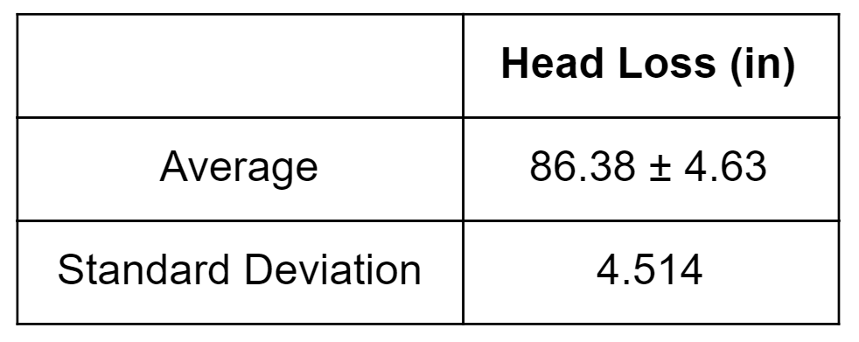

The second experiment contained a ball valve mounted in series in the system. The head loss is determined for 70, 80, and 85 degree valve closure using Equation (4). Table 2 has tabulated head loss values for the system with the ball valve mounted in the system. As expected, the head loss of the system varied non-linearly in response to linear variations in ball valve closure. Intermediate values used to to arrive at the final values in Table 2 are available in the appendix (Table A4).

Table 2 - Tabulated values of experimental head loss in the system with the ball valve at various ball valve closures.

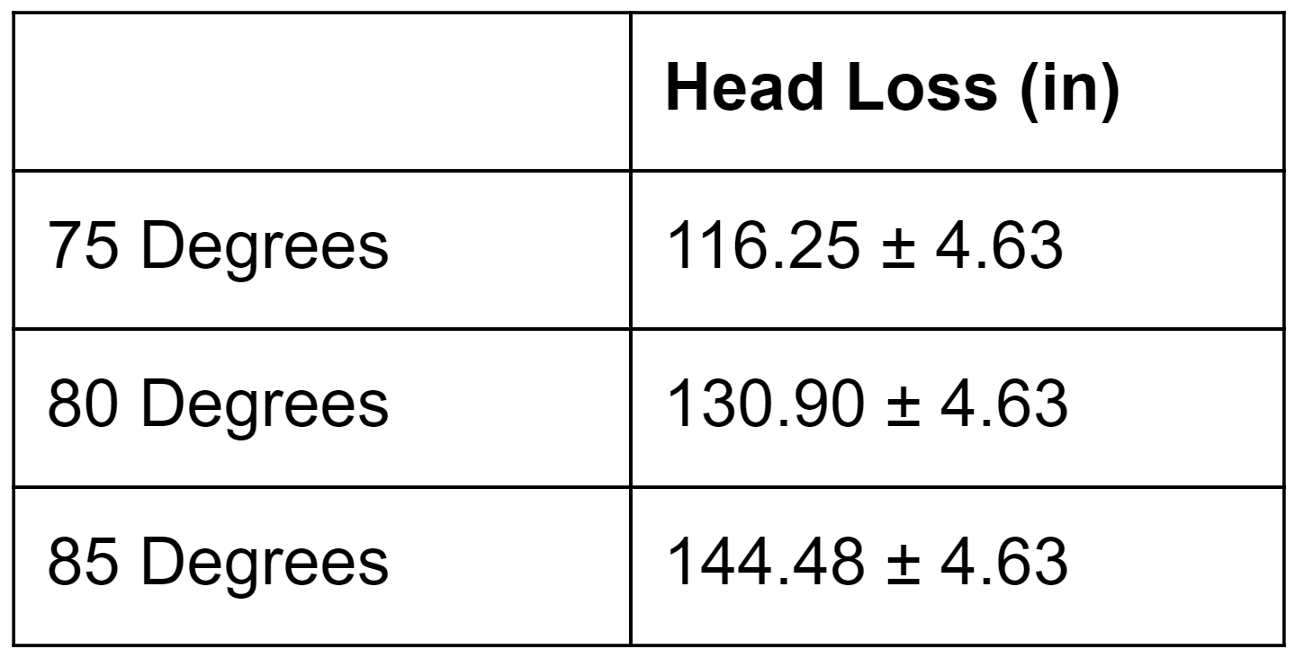

3.3: Uncertainty Analysis

Uncertainty of the values for experimental head loss listed in Table 1 and Table 2 were calculated to be +/- 4.63 in using equation (A1). This uncertainty in the head loss is due to error propagation from ruler measurements, accuracy of the sensor, and stopwatch accuracy.

**4. Summary/Conclusion:**

This experiment was conducted in order to characterize head loss of water flowing through a system using pressure and flowrate measurements. The first experiment involved calibration of a pressure transducer and characterized its transient response characteristics. The calibrated transducer was then used in a pipe flow experiment where the pressure and flow rate of the system were measured in order to experimentally determine the resulting head losses. The total head loss in any given system is the sum of major and minor losses. The losses caused by a given component or length of pipe can be determined individually. The sum of the losses due to friction in piping, and system components gives the theoretical total head loss for a system. However, a system containing complex geometries and inconsistent surface roughness can be difficult to characterize. By experimentally determining the head loss of a given system, the task of determining the losses of each component is avoided, reducing the error in the calculating head losses theoretically.

Experimentally determining head losses in a complex system is not only easier to do, but can also be more accurate. In this experiment, head loss values had 4.63 in head of uncertainty associated, with a relatively low standard deviation of 4.514. This is successful for a system that has head losses on the order of 80 to 150 inches of head loss. However, experimental determination of head loss has errors associated with it as well. Sources contributing to the error include uncertainty of the hand measurements of height, timing, fluid property variations, and flow passage geometry variation. Due to these possibilities for error, it is important to compare experimental head loss values with theoretical head loss values. Therefore, this experiment can be improved in the future through the use of a flow meter to give more precise flow measurements, and with the use of a simple system where the theoretical head loss is known. With such an experiment, the robustness of the already conducted and established experimental method will further be confirmed before use in pump prototype analysis.

**6. Appendix:**

The appendix contains information that is omitted from the report body, which is crucial for replication of this experiment. Available are extended figures of the LabView VI, pressure transducer calibration curve, and pressure transducer step response curve. Also included is sample raw data, and tabulated data used to arrive at final values for experimental head loss.

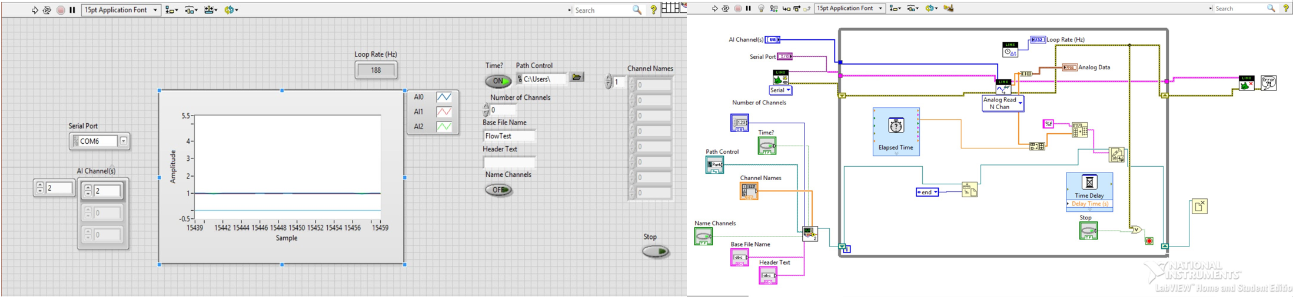

*Figure A1 - The LabView VI used to measure and store voltage readings sent to the Arduino UNO from the output of the pressure transducer. Shown is the front panel (left) and block diagram (right) of the VI.*

*Table A1 - Sample raw data from the experiment. On the left is raw data from the static 400 Psi pressure, in the middle is raw data from the 400 Psi step response, and on the right is raw data from one of the flow measurements.*

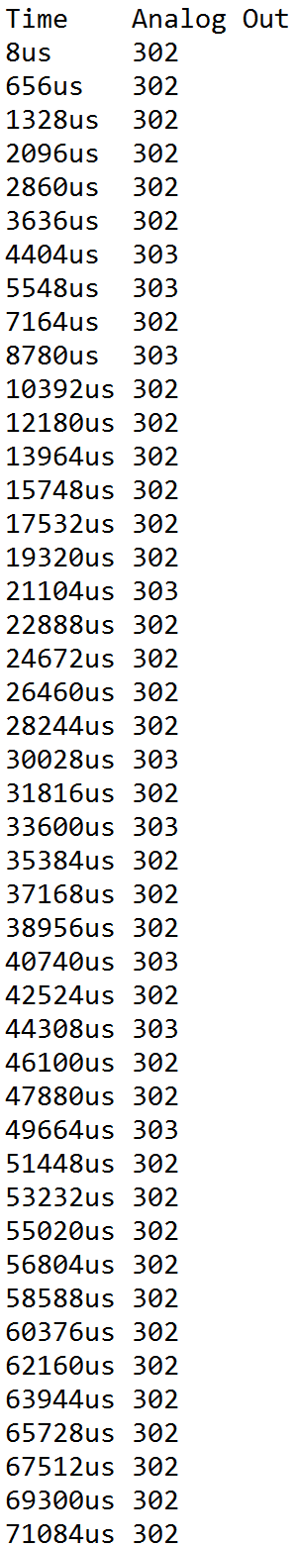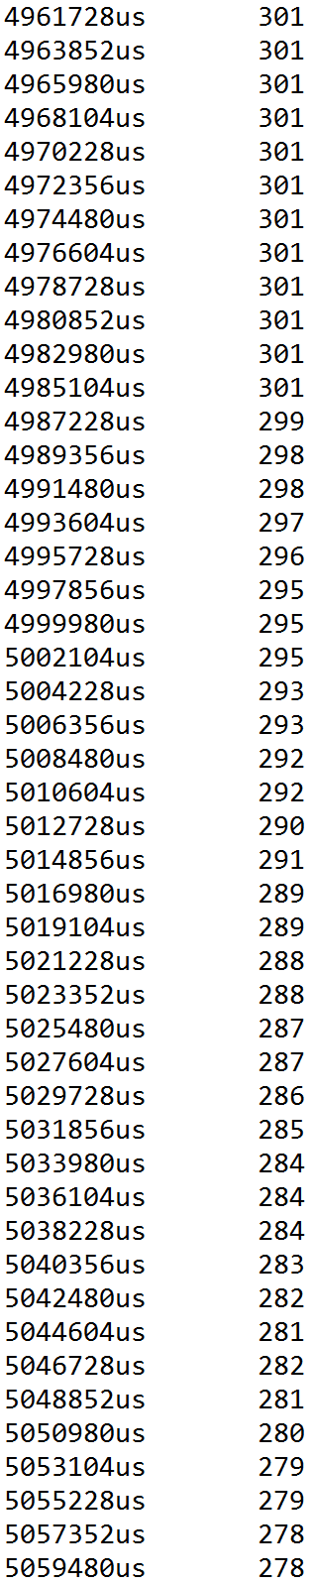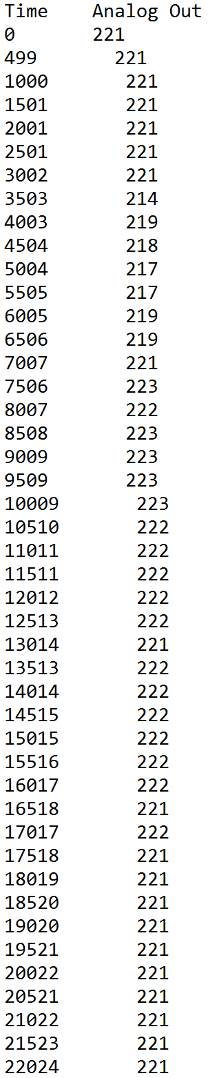

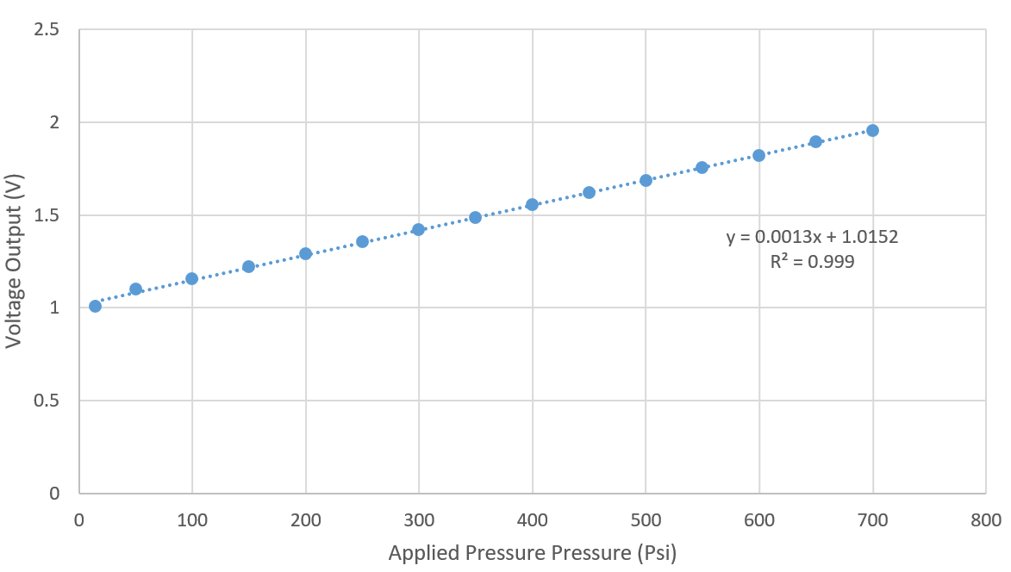

*Figure A2 - Calibration curve from static pressure tests on the pressure transducer. Curve closely matches manufacturer specs for the Ashcroft G2 pressure transducer [3].*

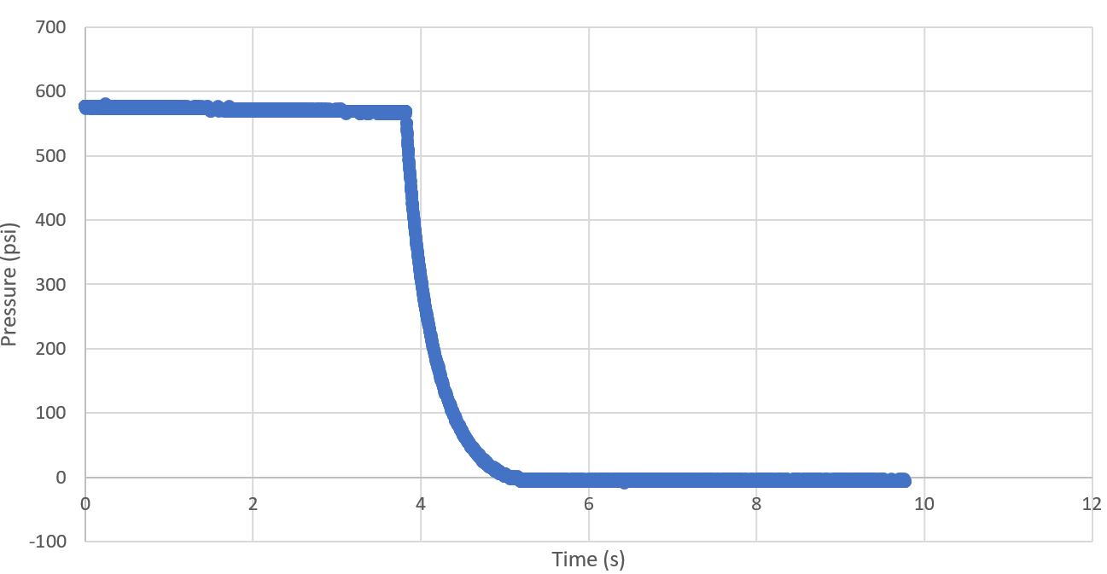

*Figure A3 - Graphs of the resulting responses from the pressure evacuation experiment at 600 Psi. Observed is the transient response of the system pressure evacuation. Response time for the Ashcroft G2 pressure transducer is 1ms, far quicker than the change in pressure for the system.*

*Table A2 - Volumetric flow rate and pressure measurements from the three trials of the system without the ball valve.*

|  |  |  |
| --- | --- | --- |
| **Trial** | **Volumetric Flow Rate (in3/s)** | **Pressure 1 (Psi)** |
| 1 | 6.87 | 10.07 |
| 2 | 7.36 | 11.96 |
| 3 | 6.91 | 10.07 |

*Table A3 - Calculated experimental head loss from the three trials of the system without the ball valve.*

|  |  |
| --- | --- |
|  | **Head Loss (in)** |
| Trial 1 | 83.64 |
| Trial 2 | 91.59 |
| Trial 3 | 83.91 |
| Standard Deviation | 4.51 |

*Table A4 - Volumetric flow rate and pressure measurements from the three trials of the system with the ball valve.*

|  |  |  |
| --- | --- | --- |
| **Trial** | **Volumetric Flow Rate (in3/s)** | **Pressure 1 (Psi)** |
| 75% closed | 5.89 | 26.99 |
| 80% closed | 4.58 | 36.39 |
| 85% closed | 2.29 | 45.79 |

*Table A5 - Values of parameters used in the calculation of head loss in Table A3 and Table A5*

|  |  |
| --- | --- |
| Tap Water Temp. (C) | 20 |
| Gravity (in/s2) | 386.4 |
| Density (lb/in3) | 0.00112 |
| Height Z1 (in) | 36 |
| Diameter at transducer, D1 (in) | 0.25 |
| Diameter at outlet, D2 ( in) | 0.5625 |
| Area at Transducer, A1 (in2) | 0.0491 |
| Area at Transducer, A2 (in2) | 0.2485 |
| Diameter of Bucket (in2) | 10 |

….+ (A1)

References

[1] Figliola, R. S., Beasley, E. D. Theory and Design for Mechanical Measurements, 5th Edition.

(2011).

[2] ME411 Lecture Notes: Lecture 11.

<http://me411.mme.pdx.edu/doku.php?id=lecture:lecture_11>

[3] Ashcroft Pressure Transducer Spec Sheet

<http://www.ashcroft.com/datasheet_pdf/upload/datasheet_g2_press_transducer.pdf>

[4] Labview Makerhub

<https://www.labviewmakerhub.com/doku.php?id=libraries:linx:start>

[5] Ashcroft G2 Pressure Transducer Schematic

<http://www.ashcroft.com/productinformation_pdf/upload/pi-page-transducer-freeze-proof-modification-for-types-g2-t2-km15.pdf>